Christina Johne
BioInformatics
Dr. Van Laar
04-04-2025

Genome Assembly and Annotation Section Report
- ABySS Assembly Statistics
Type | # of Sequences | N50(bp) | Predicted Genome Length (bp)
Unitigs | 157 | 224,380 | 5,548,818
Contigs | 83 | 468,552 | 5,582,115
Scaffolds | 59 | 749,493 | 5,583,608

Command | What it Does
abyss-pe | Main ABySS pipeline for assembling paired-end reads
abyss-fac | Generates assembly stats
abyss-scaffold | Builds scaffolds using contig path data and estimated distances.
abyss-tabtomd | to convert stats to a Markdown table
abyss-bloom-dbg | Builds the de Bruijn graph using Bloom filters.
AdjList | Creates the adjacency list of the graph.
abyss-rresolver-short | Helps resolve ambiguities in the graph using paired-end data.
abyss-filtergraph | Filters out weak/ambiguous graph edges
DistanceEst | Estimates distances between contigs based on read pairs to help guide scaffolding.
abyss-map | Maps reads back to assembled unitigs/contigs. Helps in scaffolding and resolving repeats.
SimpleGraph | Constructs scaffold paths by resolving links between contigs.
B | Sets the memory size for the Bloom filter, a space-efficient way to store all the k-mers.
k | Sets the length of the k-mers (short DNA sequences of length k) used to build the de Bruijn graph.
in=... | Specifies the input paired-end FASTQ files (read 1 and read 2 from sequencing)
name=assembly | Sets the output filename prefix to “assembly”

- Hybrid genome assembly refers to the use of multiple sequencing technologies to assemble a genome from shotgun-sequenced DNA fragments. It combines short reads (like Illumina) and long reads (like Oxford Nanopore or PacBio) to create a more complete and accurate genome. This method allows for better resolution of complex or repetitive regions while maintaining base-level accuracy. In SPAdes, a hybrid assembly can be done by adding the “--nanopore” flag to include long-read data alongside paired-end Illumina reads. This produces more contiguous and complete assemblies compared to using either data type alone.
4. Abyss report: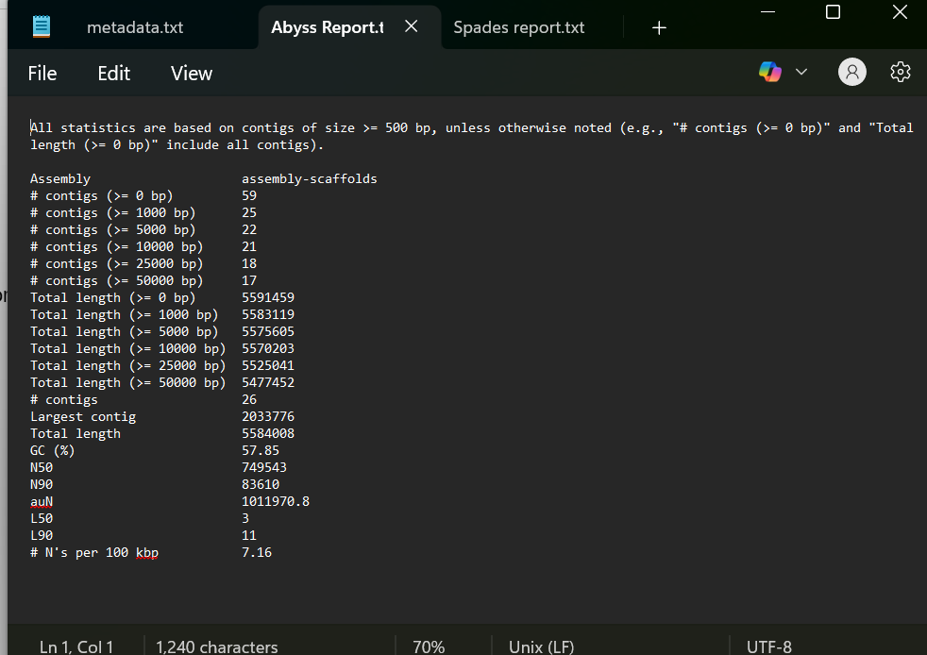

Spades report:
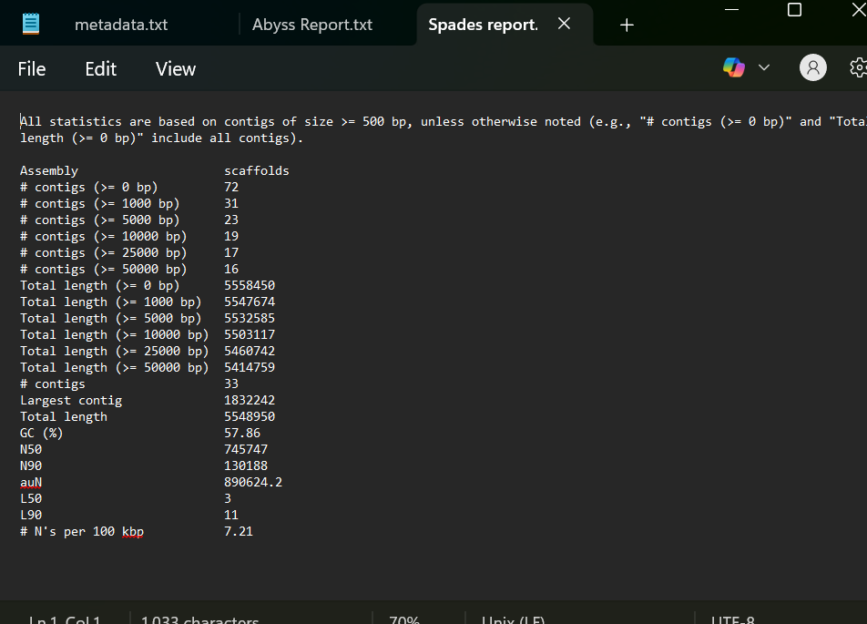

5. The best assembly is AbySS, because it has lewer contigs, a higher N50, larger max. Contigs, and has a lower number of N’s per 100kbp. Fewer contigs indicate a more contiguous and complete assembly, while a higher N50 value means that larger contigs make up most of the genome, which reflects better assembly continuity. A larger maximum contig size suggests that the assembler was able to reconstruct longer stretches of the genome without gaps. Additionally, fewer N’s per 100 kbp indicate a cleaner assembly with fewer unresolved or ambiguous regions. In this project, the ABySS assembly outperformed SPAdes in all of these areas, producing fewer, longer contigs with a higher N50 and fewer gaps. Therefore, the ABySS assembly is the better choice to use moving forward.

6. Barrnap is used to quickly identify ribosomal RNA genes, including the 16S rRNA gene, within assembled genome sequences. By running Barrnap on the assembled genome, you can extract the 16S rRNA sequence. This sequence can then be compared to databases like NCBI BLAST to identify the closest matching species. Since the 16S rRNA gene is highly conserved across bacteria but also contains species-specific variable regions, it's commonly used as a molecular marker for bacterial identification. Using the 16S rRNA gene is a good tool for species identification because it is universally present in all bacteria and archaea, it contains both conserved and variable regions, which allow for comparisons across both distant and closely related organisms and it has a large, well-curated database of known sequences to compare against. However, it's also an imperfect tool because, closely related species can have nearly identical 16S sequences, making it hard to distinguish them, some bacteria have multiple copies of the 16S gene, which can slightly differ and confuse analysis and it cannot detect horizontal gene transfer or genomic context, limiting its resolution

7. I have Pseudomonas coronafaciens, Pseudomonas tremae, Pseudomonas syringae, Pseudomonas avellanae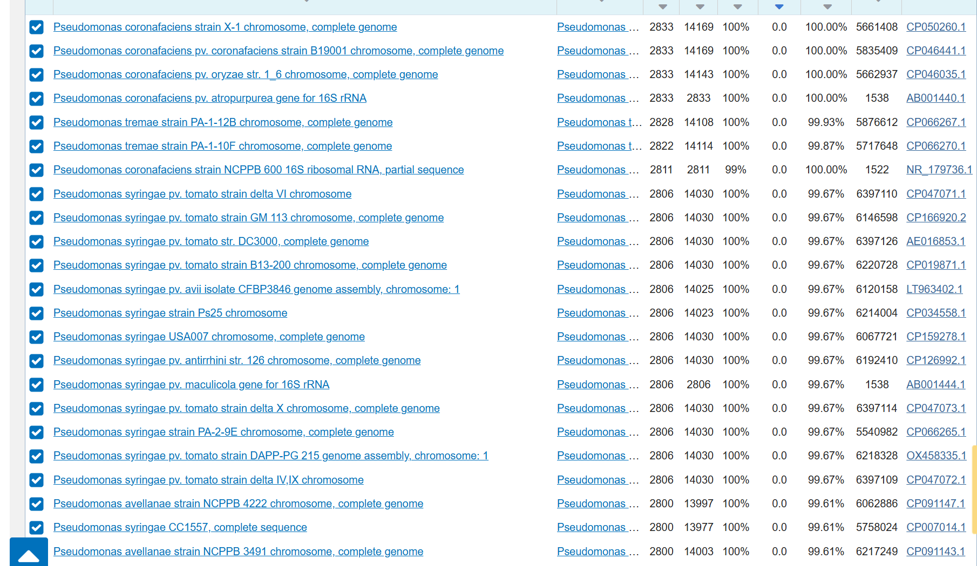

8. Genome annotation is the process of identifying and labeling functional elements within a genome sequence, such as genes, regulatory elements, rRNA and tRNA genes, coding regions (CDS), and other important features. After assembling a genome, annotation gives biological meaning to the raw DNA sequence by predicting which regions code for proteins, which may regulate gene expression, and what functions those genes might perform. Annotation is essential because a genome sequence alone is just a long string of nucleotides — without annotation, we don't know what any part of it does. By annotating a genome, we can understand the biology and function of the organism, identify genes involved in pathogenicity/ resistance/ metabolism/ etc., compare genomes across species (comparative genomics), and guide further research such as gene expression studies or evolutionary analyses.

9.
Gene | Tool Used | Location (bp) | Strand | Function
recA | GenBank/ DFAST | 176730–177769 | + | DNA recombination and repair protein
gyrA | GenBank/ DFAST | 1133250–1136262 | + | DNA gyrase subunit A (supercoiling)
dnaA | GenBank/DFAST | 1–1299 | + | DNA replication initiation

Prokka

Gene | Tool Used | Location (bp) | Strand | Function
recA | Prokka | 562616..563680 | + | Protein RecA
gyrA | Prokka | 39553..42339 | - | DNA gyrase subunit A
dnaA | Prokka | 1597580..1599115 | - | Chromosomal replication initiator protein DnaA

10.
Query Genome | Reference Genome | ANI % | Fragments Compared | Matching Fragments
spadesout/scaffolds.fasta | neighbors/tremae.fasta | 98.7167 | 1714 | 1835
spadesout/scaffolds.fasta | neighbors/syringae.fasta | 86.639 | 1506 | 1835

Notes:

# Assemble genome using SPades v4.1.0

